**CENTRO EDUCACIONAL DE ADULTOS ISABEL LA CATOLICA.** ENGLISH DEPARTMENT.

Unidad Técnica Pedagógica

Puente Alto.

**EVALUACION DE INGLÉS Nº 4.**

**“2° CICLO”**

|  |  |
| --- | --- |
| **NOMBRE DEL ALUMNO:** | **CURSO:** |

|  |  |  |  |
| --- | --- | --- | --- |
| PROFESORES | VIVIANA LUCERO  JOAN MUÑOZ | EMAILS | [PROFESORAVIVIANAINGLES@GMAIL.COM](mailto:PROFESORAVIVIANAINGLES@GMAIL.COM)  [teachernocturna@gmail.com](mailto:teachernocturna@gmail.com) |
| CONTENIDOS | PREPOSITIONS | FECHA DE INICIO | Evaluación junio. |
| NIVEL | 2ND | FECHA DE ENTREGA |  |

**INSTRUCCIONES GENERALES DEL PROFESOR.**

|  |
| --- |
| * LEA CUIDADOSAMENTE LAS INSTRUCCIONES Y COMPLETE SEGÚN LO SOLICITADO. |

**INSTRUCCCIONES**: Lee cuidadosamente antes de responder.

1. Choose true or false. Escribe en cada espacio verdadero (T) o falso (F).

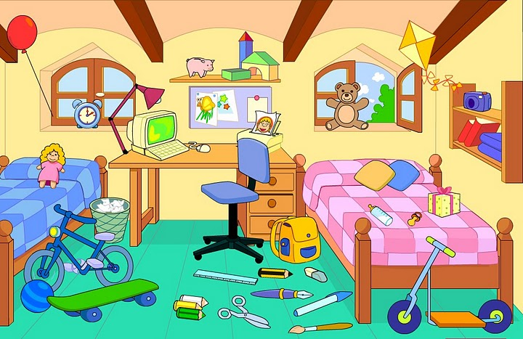

1. the chair is next to the desk ___
2. the beds are opposite the windows ___
3. the computer is under the desk ___
4. the bookcase is on the wall. ___
5. the bin is between the bed and the desk. ___
6. the lamp is on the desk. ___
7. the poster is above the shelf. ___
8. the windows are above the beds. ___
9. the clock is on the bed. ___

2. Write the correct option. Escribe la opción correcta.

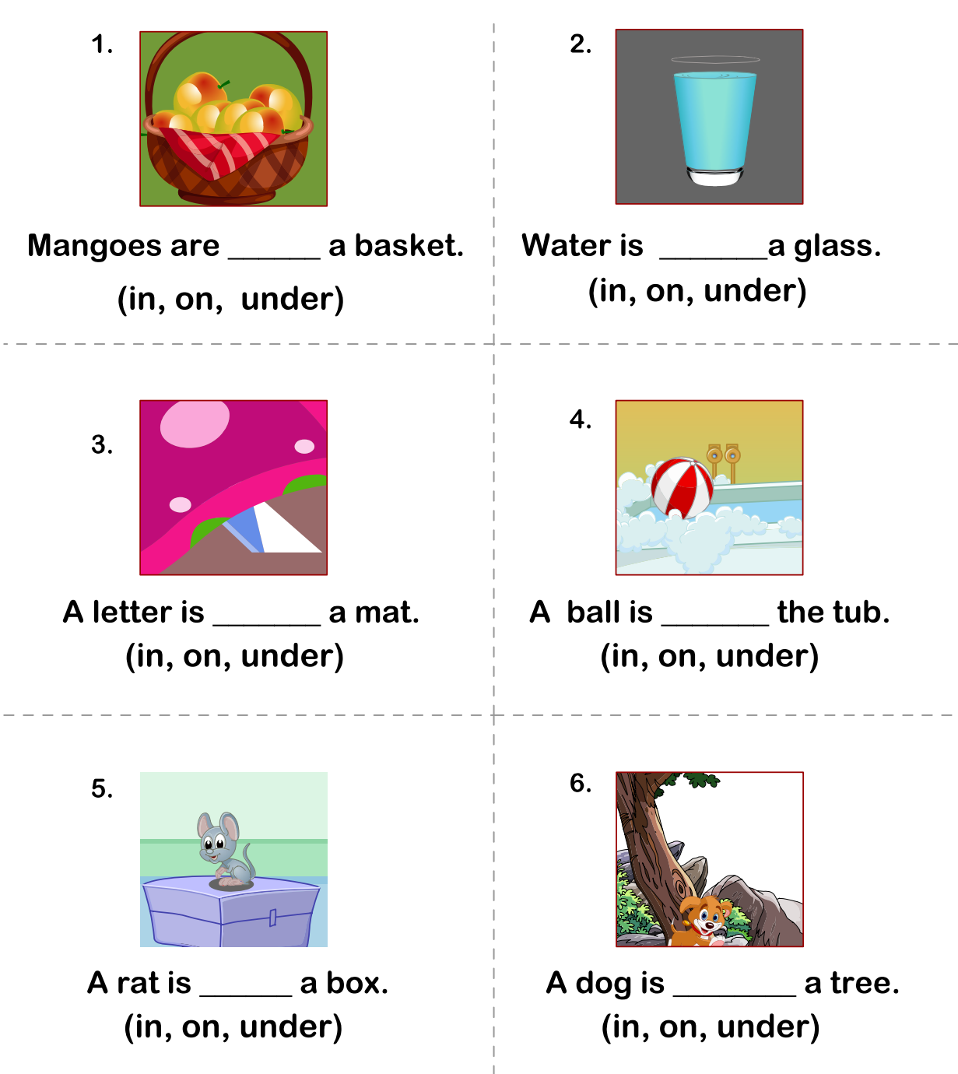

3. Put the correct preposition in each picture. Pon el nombre de la preposición en cada imagen.

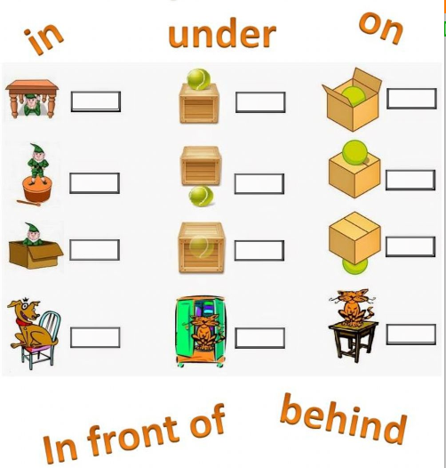

4. Draw the following statements in only 1 picture. Dibuja los siguientes estados en solo una imagen.

* There is a room with two Windows and a door, there is a couch **under** the window and a cat **on** the couch, there is also a dog **in** a box, there is a ball **between** the box and the couch, **next to** the couch is a person saying “hello”

|  |
| --- |
|  |