**CENTRO EDUCACIONAL DE ADULTOS ISABEL LA CATOLICA.** ENGLISH DEPARTMENT.

Unidad Técnica Pedagógica

Puente Alto.

**EVALUACION DE INGLÉS Nº 3.**

**“2° CICLO”**

|  |  |
| --- | --- |
| **NOMBRE DEL ALUMNO:** | **CURSO:** |

|  |  |  |  |
| --- | --- | --- | --- |
| PROFESORES | VIVIANA LUCERO  JOAN MUÑOZ | EMAILS | [PROFESORAVIVIANAINGLES@GMAIL.COM](mailto:PROFESORAVIVIANAINGLES@GMAIL.COM)  TEACHERNOCTURNA@GMAIL.COM |
| CONTENIDOS | PLACES IN TOWN | FECHA DE INICIO | Evaluación mayo |
| NIVEL | 2ND | FECHA DE ENTREGA |  |

**INSTRUCCIONES GENERALES DEL PROFESOR.**

|  |
| --- |
| * LEA CUIDADOSAMENTE LAS INSTRUCCIONES Y COMPLETE SEGÚN LO SOLICITADO. |

**INSTRUCCCIONES**: Lee cuidadosamente antes de responder.

1. Pon el nombre de cada uno de los lugares de la ciudad. Put the number in each place of town.

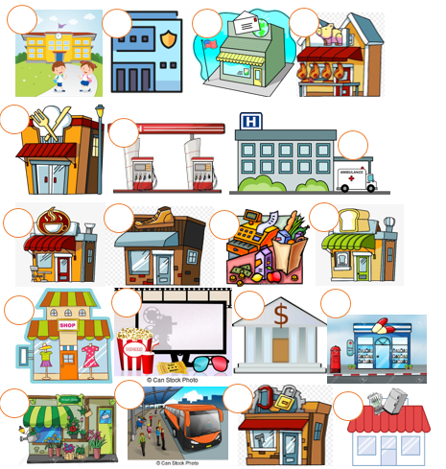

1- Movie theater 2-Hospital 3-School 4- Appliance store 5-Police station 6-Supermarket 7-Butchery 8-Bus station 9- Coffee shop 10-Restaurant 11-Bank 12-Post office 13-Gas station 14-Hardware store 15-Bakery 16-Flower shop 17-Drugstore 18-Clothing store 19-Shoe store

1. Elige la alternative correcta. Choose the correct alternative.

|  |  |  |  |  |
| --- | --- | --- | --- | --- |
| MR900153558 | MR900014451 | MR900089302 | MR900089240 | MR900089264 |
| 1. school 2. bank 3. church | 1. hospital 2. police station 3. school | a. library  b. church  c. post office | a. office  b. butcher’s  c. doctor’s | a. fast food restaurant  b. baker’s  c. bank |
| MR900014447 | MR900057299 | MR900089034 | MR900326690 | MR900297289 |
| a. post office  b. bus station  c. library | a. petrol station  b. car park  c. cinema | a. cinema  b. hotel  c. theatre | a. petrol station  b. bus station  c. restaurant | a. bank  b. cafe  c. hotel |
| MR900239657 | MR900013253 | MR900089318 | MR900280951 | MR900149635 |
| a. hospital  b. supermarket  c. bookshop | a. cinema  b. church  c. school | a. garage  b. hotel  c. cafe | a. shoe shop  b. bookshop  c. clothes shop | a. supermarket  b. café  c. baker’s |
| MR900149636 | MR900237772 | MR900221843 | MR900215569 | MR900351542 |
| a. shoe shop  b. bookshop  c. clothes shop | a. supermarket  b. restaurant  c. factory | a. library  b. sports centre  c. museum | a. hospital  b. factory  c. bank | a. school  b. cinema  c. swimming pool |
| MR900089332 | MR900089224 | MR900082899 | MR900089278 | MR900089222 |
| a. dentist’s  b. doctor’s  c. grocer’s | a. music shop  b. clothes shop  c. supermarket | a. restaurant  b. theatre  c. greengrocer’s | a. school  b. theatre  c. music shop | a. factory  b. garage  c. museum |
| MR900089298 | MR900089330 | MR900082851 | MR900440380 | MR900231110 |
| a. bookshop  b. pet shop  c. dentist’s | a. cinema  b. theatre  c. restaurant | a. supermarket  b. greengrocer’s  c. market | a. post office  b. school  c. bank | a. petrol station  b. police station  c. train station |

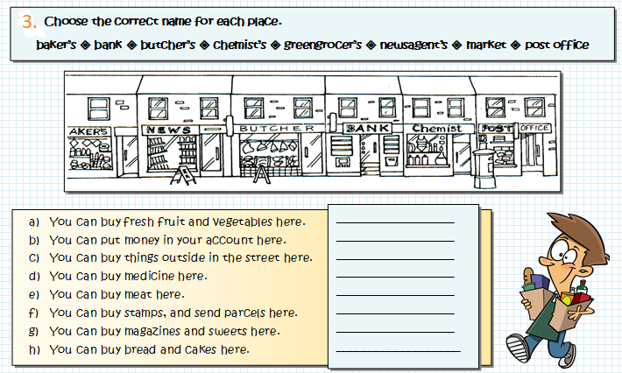

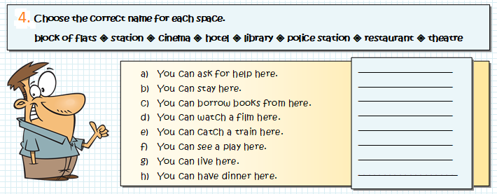

5. Encuentra en la sopa de letras los lugares de la ciudad. Find in the wordsearch the places in town.

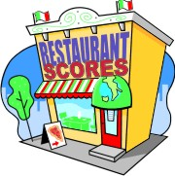

Find all the places in town in the wordsearch.

arrow cartoon blue leftarrow cartoon blue leftarrow cartoon blue leftarrow cartoon blue leftarrow cartoon blue leftarrow cartoon blue left

|  |  |  |  |  |  |  |  |  |  |  |  |  |  |  |  |  |  |  |  |
| --- | --- | --- | --- | --- | --- | --- | --- | --- | --- | --- | --- | --- | --- | --- | --- | --- | --- | --- | --- |
| F | M | I | J | U | W | W | G | T | Q | X | B | A | K | E | R | Y | B | U | C |
| H | Q | M | B | N | M | F | E | B | D | F | P | R | O | N | N | X | B | O | X |
| S | H | S | C | Z | Q | X | Z | A | P | T | H | C | R | U | H | C | N | B | S |
| L | C | H | U | E | O | L | V | V | N | E | N | F | Y | U | G | Q | U | K | M |
| Q | B | O | M | P | C | Z | N | G | A | L | X | A | V | J | C | Y | Y | B | X |
| O | I | P | N | C | E | I | F | I | Z | I | H | T | R | X | O | F | X | D | X |
| Y | H | P | Y | V | X | R | F | L | W | X | P | O | M | U | B | P | K | G | L |
| P | O | I | R | C | T | O | M | F | I | D | M | U | S | U | A | E | V | C | Y |
| S | Z | N | D | M | H | Q | F | A | O | T | J | P | N | P | E | T | I | D | Q |
| Y | U | G | C | T | V | B | U | C | R | T | E | P | T | H | I | S | S | W | S |
| M | D | C | J | B | A | N | K | E | X | K | S | K | U | Y | D | T | U | E | D |
| N | U | E | I | Y | O | H | Y | L | V | W | E | O | H | A | J | V | A | M | R |
| C | K | N | G | Q | P | R | U | E | B | L | M | T | P | H | A | D | G | L | S |
| G | H | T | P | R | A | R | S | A | Y | U | L | C | R | S | U | U | Y | X | A |
| B | U | R | A | R | A | T | S | P | O | R | T | S | C | E | N | T | R | E | I |
| C | S | E | B | Y | Q | K | J | A | T | T | J | C | I | N | E | M | A | H | R |
| M | U | I | D | A | T | S | O | C | I | Y | P | O | H | F | Z | B | C | C | W |
| Z | L | F | I | R | G | K | H | O | R | J | U | Q | M | E | F | I | K | K | B |
| T | Z | H | S | X | P | Q | R | I | C | S | X | Y | O | B | R | W | C | N | Z |
| B | E | W | Q | Y | B | N | W | T | P | F | J | J | P | G | U | S | H | J | J |



[](http://www.clipartlord.com/wp-content/uploads/2013/10/hospital5.png)[](http://northsidecommunitychurch.com/wp-content/uploads/2012/09/Library-Clipart-CR1.gif)