Centro Educacional de Adultos NAME:
Isabel la Católica – Puente Alto
https://isabellacatolica.cl/ __________________________________
WORKSHEET NUMBER 2
“NUMBERS-NÚMEROS”

ASIGNATURA | ENGLISH | CURSO | 1° NIVEL
PROFESOR | VIVIANA LUCERO J. JOAN MUÑOZ S. | CORREO PROFESOR | PROFESORAVIVIANAINGLES@GMAIL.COM  TEACHERNOCTURNA@GMAIL.COM
FECHA DE  INICIO | 15 DE MARZO 2021 | FECHA DE TERMINO | 22 DE MARZO DE 2021
CONTENIDOS | NUMBERS

INDICACIONES DEL PROFESOR.
DEBES COMPLETAR LA GUÍA CON LÁPIZ PASTA AZUL O NEGRO. SE ADMITEN CORRECCIONES CON CORRECTOR. PUEDES USAR DICCIONARIO FÍSICO U ONLINE. PUEDEN AYUDARSE EN SUS CASAS CON LA WEB.

Ejemplos
https://www.youtube.com/watch?v=dNP6L6y7ZEM&t=3s VE EL VIDEO PARA PRACTICAR
PRONUNCIACIÓN.

Actividad de ejercitación.
VAMOS A EJERCITAR EN LAS SIGUIENTES HOJAS.

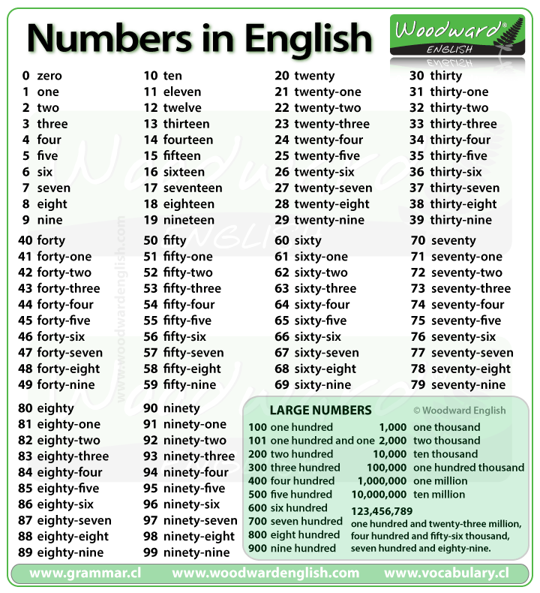

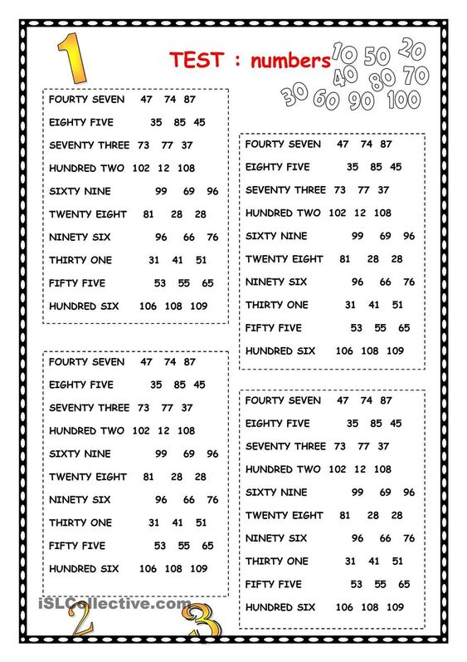

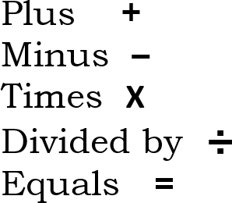
CROSSWORD

NUMBERS
- Read the clues and fill in the missing words.
1 2 3
S E V E N T E E N
4
5
6
7
8
9
10
11 12
13
14
15
16
17
18
19

ACROSS
  - How much is 9 plus 8?
- How much is 10 minus 7?
- What is 5 plus 4?
- How much is 9 plus 9?
11. How much is 10 times 100? “One ….”
- How much is 45 minus 44?
- How much is 25 divided by 5?
- How much is 31 plus 21?
- What is 96 times 0?
- How much is 120 divided by 2?

- How much is 103 minus 78?

DOWN
- How much is 69 plus 9?
- How much is 21 minus 10?
- What is 47 plus 33?
- How much is 63 divided by 9?
- How much is 100 divided by 10?
- What is one half of one? “One ….”
- How do you say this number:
1,000,000? “One ….”
12. How much is 90 plus 10? “One ….”
- What is 100 divided by 25?
- How much is 18 plus 12?

S | E | T | H | I | R | T | Y | N | I | N | E | L | E | V | N | E | T
I | G | H | Y | T | A | S | X | T | Y | F | I | X | S | T | H | R | W
E | S | E | V | E | N | I | N | Y | T | T | E | E | E | D | R | D | E
F | W | N | E | T | Y | O | N | R | E | H | Q | M | V | R | W | Z | N
F | I | G | E | W | E | N | I | N | E | T | Y | Y | E | L | P | E | T
E | R | F | L | P | Numbers 1 - 100  Below are 16 numbers between 1  and 100. Can you find them all?  16 numbers …12 minutes! |  |  |  |  |  |  |  | N | R | E | I | Y
Z | S | A | T | E |  |  |  |  |  |  |  |  | T | A | F | G | S
U | I | R | E | Y |  |  |  |  |  |  |  |  | Y | U | J | H | I
A | S | E | K | L |  |  |  |  |  |  |  |  | O | U | M | T | X
G | A | I | D | C |  |  |  |  |  |  |  |  | N | B | E | Y | A
F | I | G | D | A |  |  |  |  |  |  |  |  | E | C | H | E | I
S | I | H | T | Y |  | 2  7  11  14  20  26  39  44 |  |  |  | 50  53  65  71  80  88  90  100 |  |  | G | S | D | E | R
L | E | T | F | E |  |  |  |  |  |  |  |  | O | F | D | A | S
E | V | Y | O | R |  |  |  |  |  |  |  |  | T | J | N | O | I
E | Y | E | R | U |  |  |  |  |  |  |  |  | E | W | E | T | X
L | E | I | T | O |  |  |  |  |  |  |  |  | F | E | O | Y | T
E | X | G | R | F |  |  |  |  |  |  |  |  | O | K | C | N | Y
V | T | H | R | Y |  |  |  |  |  |  |  |  | E | E | Q | U | F
E | H | T | V | T |  |  |  |  |  |  |  |  | K | E | A | V | I
N | E | E | C | R |  |  |  |  |  |  |  |  | N | U | B | A | V
E | R | E | J | O |  |  |  |  |  |  |  |  | X | M | E | S | E
F | T | Y | I | F | O | P | N | E | E | T | R | U | O | F | U | T | Y
A | B | N | E | W | N | T | E | Y | T | I | Y | F | O | R | Y | U | O
F | I | F | T | Y | T | H | R | E | E | E | M | A | B | U | T | E | E
T | E | C | S | N | U | G | H | T | Y | U | Q | Z | E | I | R | P | A
T | W | E | N | T | Y | O | E | O | N | E | H | U | N | D | R | E | D

