

**Centro Educacional de Adultos** NOMBRE Y APELLIDO ESTUDIANTE:

**Isabel la Católica – Puente Alto**

<https://isabellacatolica.cl/> ______________________________

**GUIA DE ACTIVIDADES. SEGUNDO NIVEL N°3**

**PLACES IN TOWN.**

|  |  |  |  |
| --- | --- | --- | --- |
| ASIGNATURA | INGLÉS | CURSO | SEGUNDO NIVEL ______ |
| PROFESOR | VIVIANA LUCERO  JOAN MUÑOZ | CORREO PROFESOR | PROFESORAVIVIANAINGLES@GMAIL.COM  TEACHERNOCTURNA@GMAIL.COM |
| FECHA DE  INICIO | 23/04 | FECHA DE TERMINO | 30/04 |
| CONTENIDOS | * GIVING DIRECTIONS. | | |

**INDICACIONES DEL PROFESOR.**

|  |
| --- |
| -LEE CUIDADOSAMENTE LAS INSTRUCCIONES Y COMPLETA LOS EJERCICIOS A CONTINUACION. |

**Ejemplos**

|  |
| --- |
| Places in the City Vocabulary in English (with Pictures) • 7ESL | Ciudad en  ingles, Material escolar en ingles, Libros para aprender ingles |

**VOCABULARY IN CONTEXT.**

* Study the vocabulary and then complete the exercises to study.

** * CINEMA**

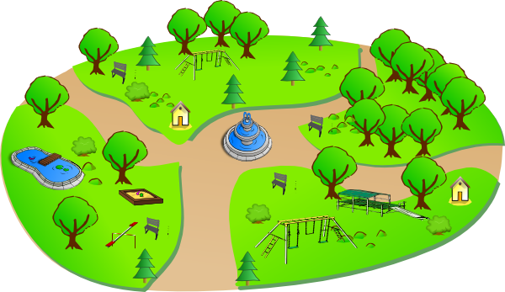 **\* PARK**

** * HOSPITAL**

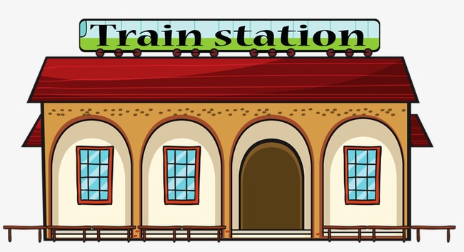 **\* TRAIN STATION**

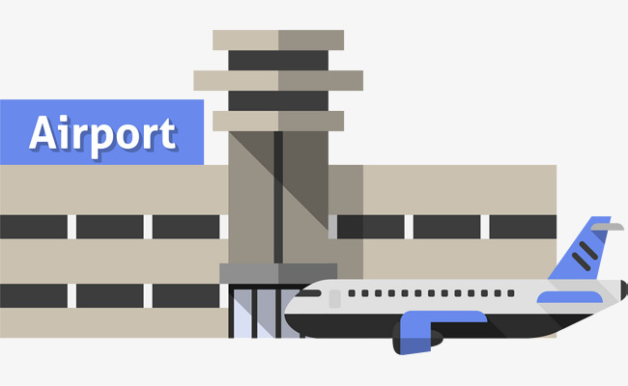 **\* AIRPORT**

** * LIBRARY**

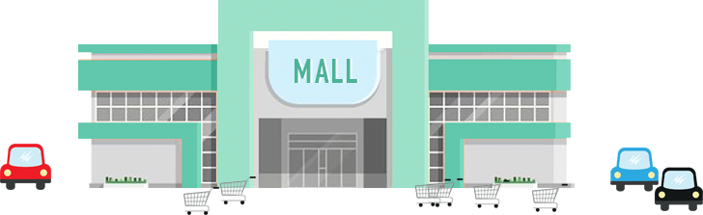 **\* MALL**

** * POLICE STATION**

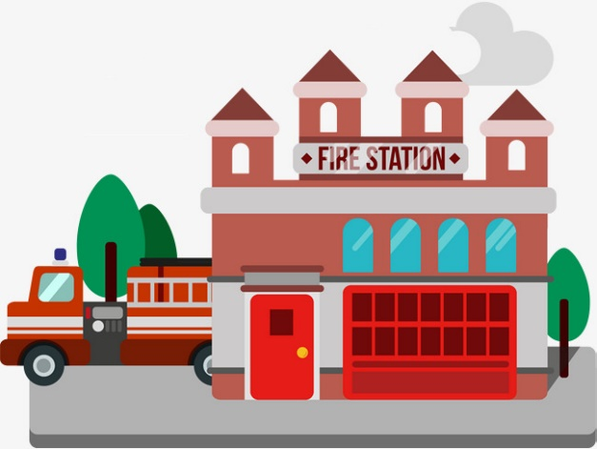 **\* FIRE STATION**

** * DRUGSTORE**

** *ZOO**

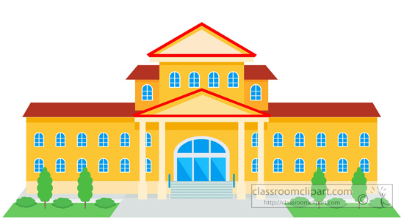 **\*MUNICIPALITY**

**\* SCHOOL**

1. Find all the places in town in the word search. Encuentra las siguientes palabras en la sopa de letras.



|  |  |  |  |  |  |  |  |  |  |  |  |  |  |  |  |  |  |  |  |
| --- | --- | --- | --- | --- | --- | --- | --- | --- | --- | --- | --- | --- | --- | --- | --- | --- | --- | --- | --- |
| F | M | I | J | U | W | W | G | T | Q | X | B | A | K | E | R | Y | B | U | C |
| H | Q | M | B | N | M | F | E | B | D | F | P | R | O | N | N | X | B | O | X |
| S | H | S | C | Z | Q | X | Z | A | P | T | H | C | R | U | H | C | N | B | S |
| L | C | H | U | E | O | L | V | V | N | E | N | F | Y | U | G | Q | U | K | M |
| Q | B | O | M | P | C | Z | N | G | A | L | X | A | V | J | C | Y | Y | B | X |
| O | I | P | N | C | E | I | F | I | Z | I | H | T | R | X | O | F | X | D | X |
| Y | H | P | Y | V | X | R | F | L | W | X | P | O | M | U | B | P | K | G | L |
| P | O | I | R | C | T | O | M | F | I | D | M | U | S | U | A | E | V | C | Y |
| S | Z | N | D | M | H | Q | F | A | O | T | J | P | N | P | E | T | I | D | Q |
| Y | U | G | C | T | V | B | U | C | R | T | E | P | T | H | I | S | S | W | S |
| M | D | C | J | B | A | N | K | E | X | K | S | K | U | Y | D | T | U | E | D |
| N | U | E | I | Y | O | H | Y | L | V | W | E | O | H | A | J | V | A | M | R |
| C | K | N | G | Q | P | R | U | E | B | L | M | T | P | H | A | D | G | L | S |
| G | H | T | P | R | A | R | S | A | Y | U | L | C | R | S | U | U | Y | X | A |
| B | U | R | A | R | A | T | S | P | O | R | T | S | C | E | N | T | R | E | I |
| C | S | E | B | Y | Q | K | J | A | T | T | J | C | I | N | E | M | A | H | R |
| M | U | I | D | A | T | S | O | C | I | Y | P | O | H | F | Z | B | C | C | W |
| Z | L | F | I | R | G | K | H | O | R | J | U | Q | M | E | F | I | K | K | B |
| T | Z | H | S | X | P | Q | R | I | C | S | X | Y | O | B | R | W | C | N | Z |
| B | E | W | Q | Y | B | N | W | T | P | F | J | J | P | G | U | S | H | J | J |

1. Make a list of 10 things that are in your city or town. Haz una lista de 10 lugares que hay en tu ciudad.

1.

2.

3.

4.

5.

6.

7.

8.

9.

10.

1. Write the correct name of these places. Escribe el nombre correcto en cada uno de los lugares.

|  |  |  |
| --- | --- | --- |
| Resultado de imagen para hospital coloring    _ _ _ _ _ _ _ _ | Resultado de imagen para school coloring _ _ _ _ _ _ | Resultado de imagen para restaurant coloring  _ _ _ _ _ _ _ _ _ _ |
| Resultado de imagen para farm coloring  _ _ _ _ | Resultado de imagen para police station coloring _ _ _ _ _ _ _ _ _ _ _ _ _ | |

1. Match the description with the image. Une la descripción con la imagen (pon la letra en cada imagen)
2. An institution for educating children.
3. A place used for raising domestic animals.
4. People go when they feel sick or have an accident.
5. People pay to eat meals here.
6. A place where police officers work.